CREATE & CONFIGURE IBM CLOUD SERVICE CREATE THE TEXT-TO-SPEECH SERVICE

|  |  |
| --- | --- |
| Date | 07 NOV 2022 |
| Team ID | PNT2022TMID07561 |
| Project name | Personal assistance for senior-who are self-reliant |

Installation of Watson-TTS Client library Provided for Python: Code:

Pip install –upgrade IBM WATSON >=6.1.0”

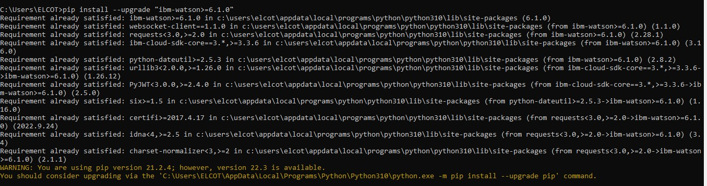

Service Creation Status & Credential Details:

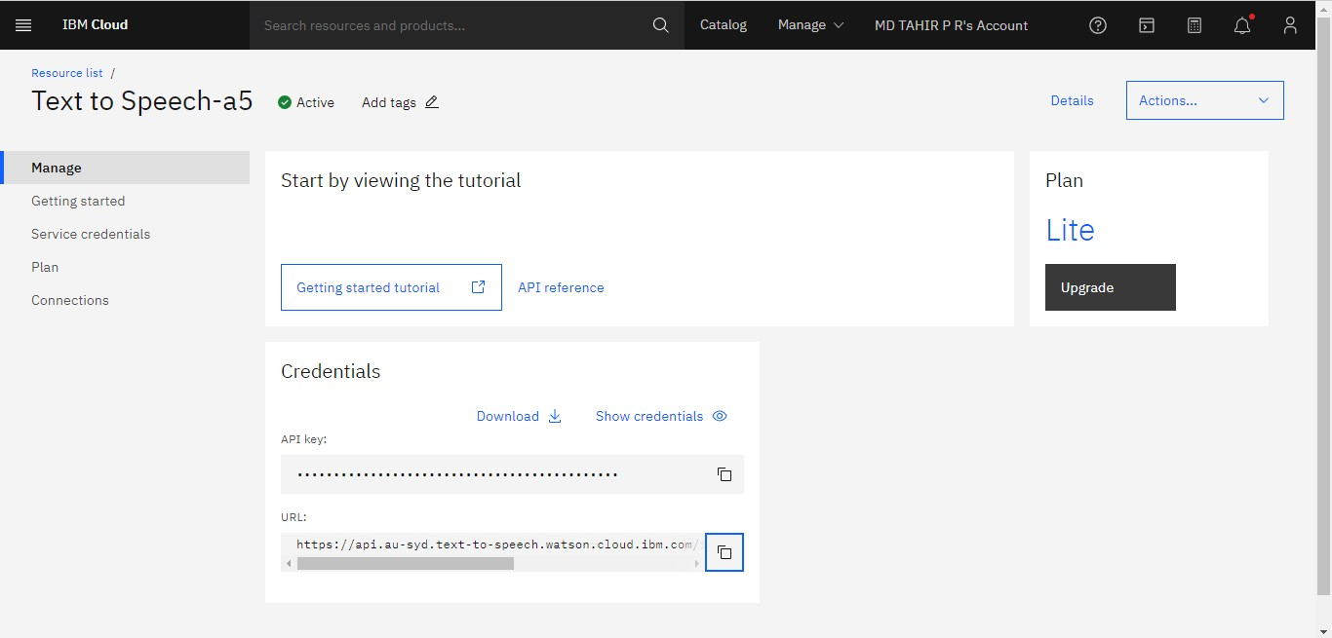

**STATUS :** ACTIVE

Execution & Test Run of Program to Access TTS:

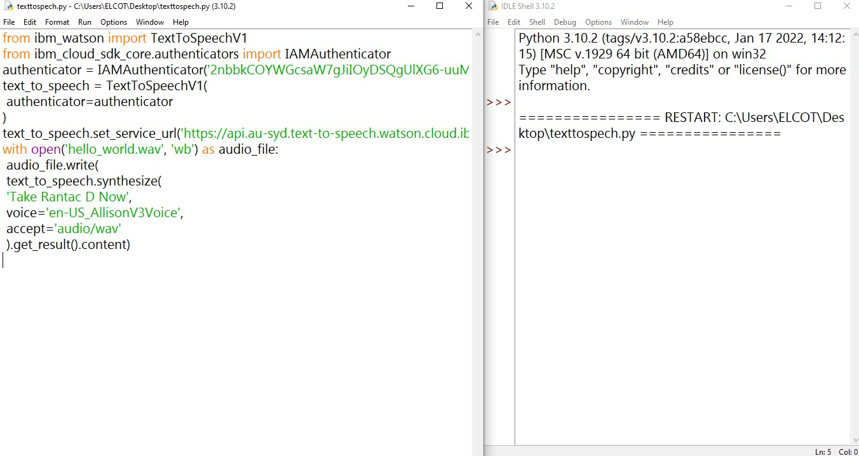

**RESULT :** SUCCESSFULLY CREATED